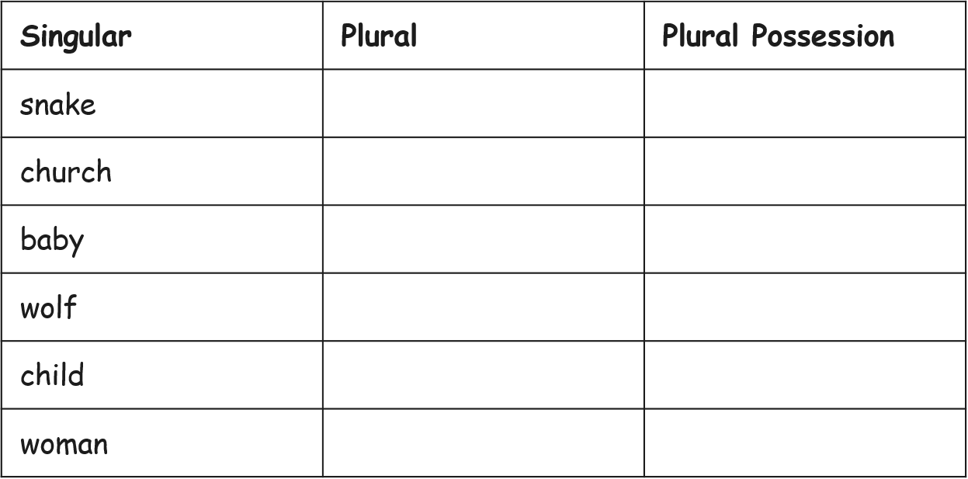

teeths / teeth’s / teeths’ / teeths’s

All of the cavities must be filled.

lices / lice’s / lices’ / lices’s

Some eggs are difficult to remove.

planets / planet’s / planets’ / planets’s

The orbits all centre around the star.

Read the sentences below and decide which word should go in the gap. Which one accurately shows **plural possession**?

**Which Word Is Correct?**

Try this activity. Read the singular form of the noun, make the noun **plural** and then show whether you add an apostrophe on its own (‘) or an apostrophe s (‘s) to show **plural possession**.

**Plural Possession**