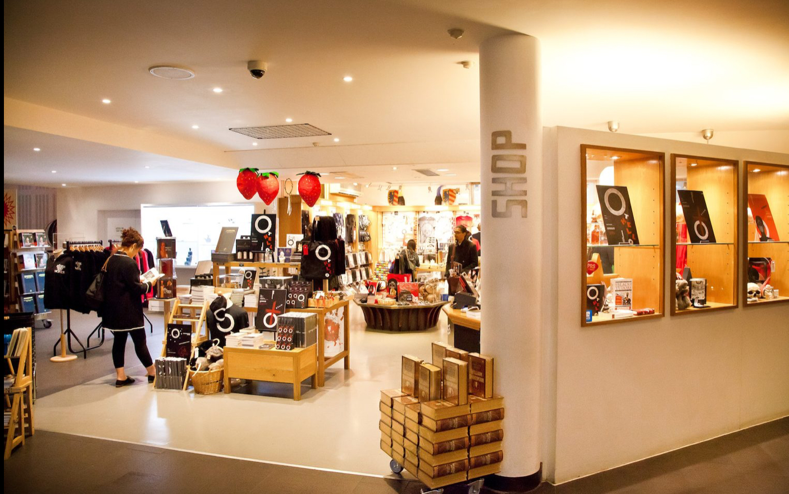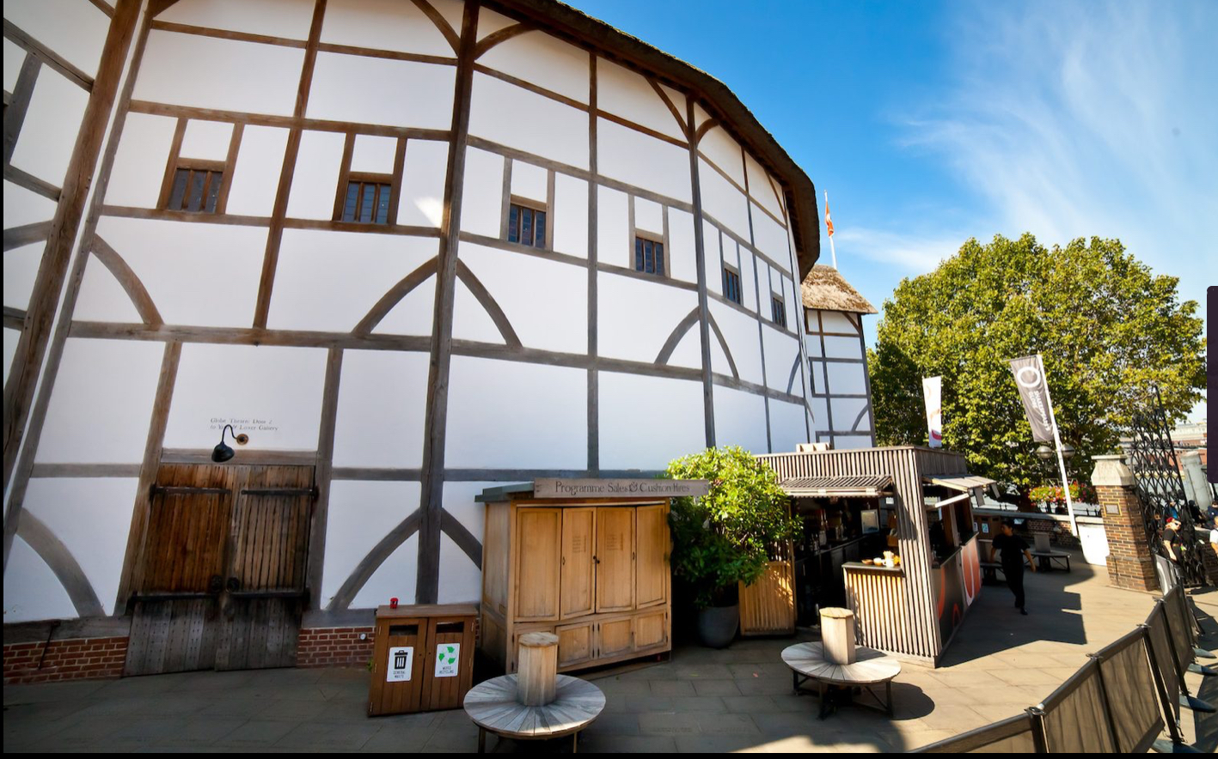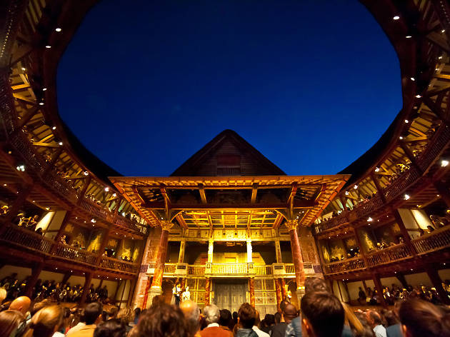

Plays, dances and poems

We have a lots of plays and poems performed by actors.

Some will make you laugh or cry and you’ll be wondering what is coming next!

In the summer we do a

midnight play under the stars which is very popular. Be sure book a ticket in advance!

Visitor information

We open at 2pm and close at 5pm.

Entry costs £10 per person and free for children under 5.

We will end with a song, dance or a poem and sometimes we will do some plays.

We also have a gift shop, so you can get something like a bag for life or a toy.

You can also buy a selection of food and drink from our Cafe.

The Globe Theatre

**Home of Shakespeare and his famous plays!**