Dear Parents and Carers

Welcome back! We hope you had a fantastic holiday and the children have enjoyed the start to the year. It has been wonderful to see the children return to school happy and full of enthusiasm. We are writing to share some information about life in year 4.

Our two classes are Kingfishers class with Mrs Mac Taggart and Otters class with Mrs McIntyre. Our teaching assistants are Mrs Jones and Mrs Crudgington

Curriculum
Year 4 begins with excitement and mystery as we unravel and explore the fascinating world of the ancient Egyptian and Mayan cultures with a particular emphasis on buildings and architecture. We began this project with the question: “Who were the Greatest Builders?” As the project evolves we will investigate how these ancient civilisations lived and the variety of roles people had. We will listen to and read stories with historical links, leading to diary, writing and creating a pop-up information text. In R.E. we explore ‘People of God’ focusing on the story of Noah and we learn all about the Trinity. More information can be found on https://www.stwilfrids-hh.school/web/curriculum/363101

Reading at Home
Even when your child enjoys reading and reads well on their own, they still need to read aloud all the way through their Key Stage Two years. Books will be made available from the school library and each year group has a selection of books that your child can borrow and read at home. Further information about how to record your child’s reading at home will be sent out in the coming weeks along with further details of our ‘Reading Rewards Time’ incentive for all KS2 pupils. The recording of reading at home will begin in the week beginning 21st September. However, it is important that children continue to read right from the first few days of term and this will support them to develop a life-long love of reading during their time at St.Wilfrid’s.

Homework
Homework will be set weekly from the week beginning 21st September onwards. Maths and English homework is set on a Wednesday and needs to be submitted by the following Tuesday.

Maths homework will either be an activity on the website MyMaths, or a task based on what has been covered in class that week set on Microsoft Teams. The English homework is usually a writing task, based on a prompt such as an element of grammar or punctuation, which will be set on Microsoft Teams. In addition, children will be set spellings to practise and these will be tested on a Thursday. These will be a mixture of words from the statutory ‘word lists’ and those with particular spelling patterns. Spellings will be set on ‘Spelling Shed’. Times tables and related division facts should be practised on an on-going basis, ideally a few minutes daily. Children are expected to know these and be making progress with them. ‘Times Tables Rockstars’ is an excellent website to use to practise these and children have been provided with logins to access this at home. All children are expected to complete and submit their homework on time. Children have been given their log-in details for the above websites, but if these have been misplaced, please inform the class teacher.

PE
This term, PE is on a Tuesday and a Thursday and on these days, children should attend school in their PE kit. If there is any reason why your child cannot participate in a PE session, please let the class teacher know via the year group email address. As an alternative, or in addition to plimsolls, sports trainers are allowed in the juniors. These are particularly useful during the winter months as it allows the field to be used for outside PE. PE is only cancelled in the event of heavy rain, icy or extremely cold conditions, therefore a pair of jogging bottoms and a sweatshirt (ideally navy) are allowed. Children with pierced ears must be able to remove their own earrings or cover these with tape brought from home.

Water bottles and snacks
Please remember to bring in a water bottle and a healthy fruit or savoury snack (for example, fresh fruit, a bagel, raisins) for break time. Please ensure any snacks are both nut and egg free.

Uniform
Please ensure your child has a waterproof coat in school every day. Children will only stay indoors at playtimes if it is raining heavily. All clothing, including PE kit, should be labelled with your child’s surname.

We are looking forward to a great Autumn term. If at any point you have a message for your child’s teacher, please contact us through the year group email: year4@stwilfrids-hh.school
Please do contact us if you have any questions.

Best Wishes

Mrs Mac Taggart and Mrs McIntyre

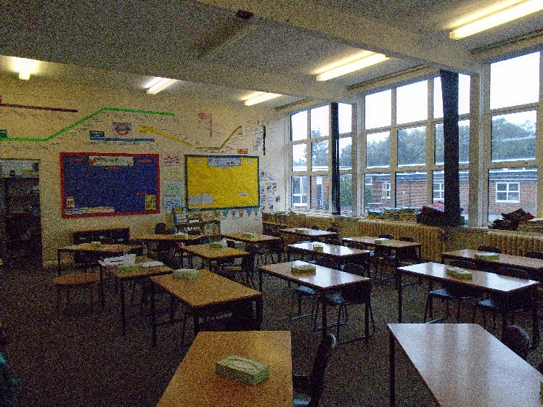
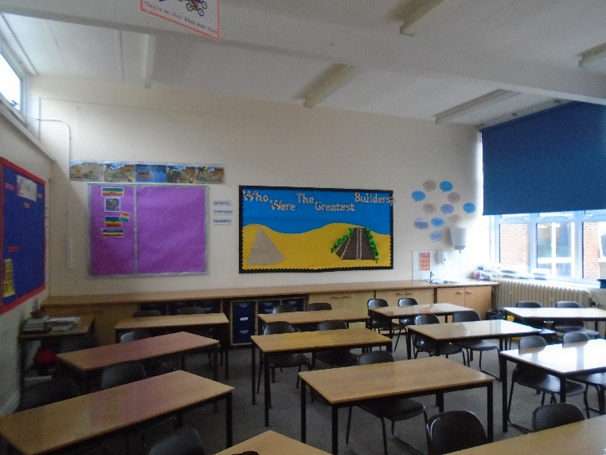
Otters Classroom
Kingfishers Classroom

