English

Lesson 2

1. Match the two parts of the personification sentences. Use one from the bright blue side for the start of the sentence and match it with one from the dark blue side.

For example:

My alarm clock yells at me every morning

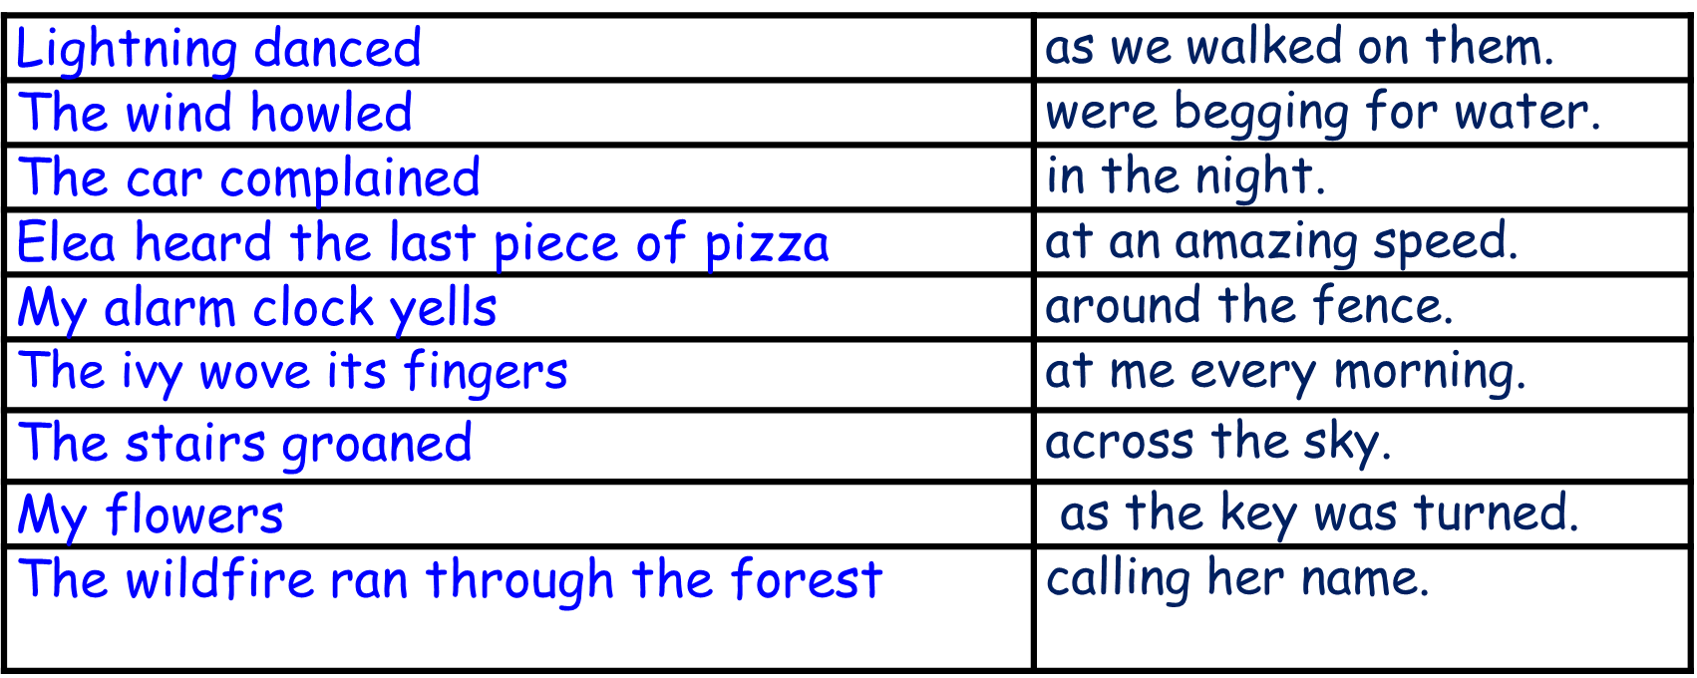

2. Write some personifications of your own:

Can you personify:

Cars

Trees

The moon

You can use your own objects to personify or the ones above. Try to write 2 per object.

Answers

Lightning danced across the sky.

The wind howled in the night.

The car complained as the key was turned.

Elea heard the last piece of pizza calling her name.

The ivy waves its fingers around the fence.

The stairs groaned as we walked on them.

My flowers were begging for water.

The wildfire ran through the forest.