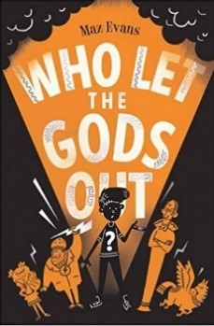

Who Let the Gods out – Chapter 13

After you have read Chapter 13 of ‘Who let the Gods out’ work through these VIPERS questions (Vocabulary, Inference, Prediction, Explain, Retrieve, Summarise). Write the answers in your book.

V | p.149 Circle the word that is closest in meaning to ‘elaborate’  plain intricate smart difficult  p150 What word is used to describe the sound the horse makes?
I | Pp147-148 Hermes is a thoughtful and considerate driver. Do you agree? Explain your answer using evidence from the text.
P | How do you think the reader knew Zeus’s wedding would probably be a disaster like it was?
E | p.153 Explain how the author surprises us with Zeus’s appearance in this chapter. Give evidence from the text.
R | What are the names of Zeus’s two brides?
S | Decide whether each statement is fact or opinion  Travelling by constellation is a terrifying experience for anyone  The immortal road system runs exactly underneath the mortal one  The bridesmaids wore salmon pink  Brides should always wear white to a wedding.

