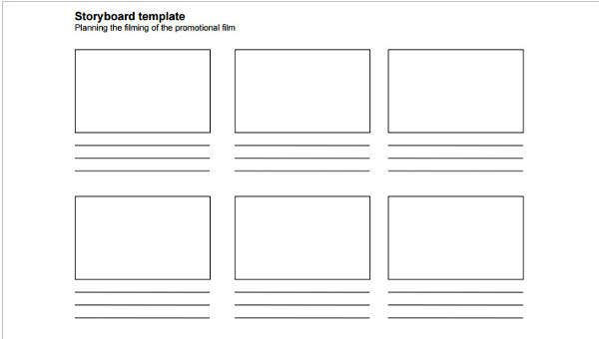

**You picked some flowers from your neighbour’s garden.**

**You said unkind things to your brother or sister when you were having an argument.**

**You borrowed your friend’s toy without asking and have broken it.**

**You knocked your mum’s favourite vase off the table when playing with a ball inside.**

**You told a lie to your teacher to get someone else in trouble.**

**You have hurt your friend in a game at playtime.**