Parts of a flower experiment  (Twinkl worksheet attached)  https://www.twinkl.co.uk/resource/au-t-1723-parts-of-a-plant-and-flower-labelling-worksheet-australia | - Can you dissect a flower?  - Go out into the garden and pick a flower, investigate the parts of a flower  - Lay the flower out on a sheet of paper/ tray and begin to dissect the key parts of the flower  - Find the flower, stem and leaf  - Label the parts of a flower on the twinkl worksheet  - Challenge: Can you find any other parts of flower and label it on the picture?  e.g. Root, Petal, Pollen | 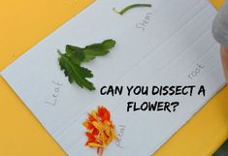  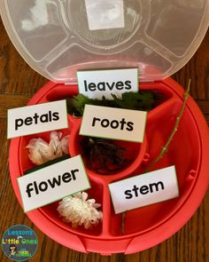
Create your own animal habitat | - Collect natural materials from around the garden to create a mini animal habitat  - Choose from an animal you may find in your garden  e.g. Insect, Bird, or Reptile  - Think about what your animal may need to survive  - Discuss with an adult  - Take a picture of your mini habitat that you have created  - Challenge: Write a list of instructions on how you made your mini animal habitat | 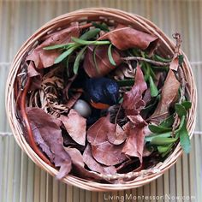  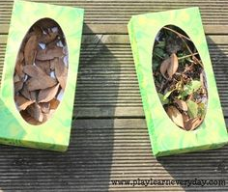  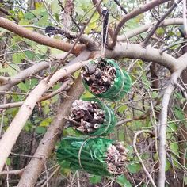
Become a nature detective  (Can use worksheet template or complete in green book) | - Take a walk around the garden/ outdoors  - Look for evidence of things that show what season it is: Spring  - Use all your senses to investigate  - Ask: What might we see, hear, smell and feel that tell us that it is Spring?  - Make a list/ draw a picture of all the things that were found on the nature walk, any questions you might want to know about Spring or what was found
Nature Art | - Investigate the different texture of trees/ leaves etc.  - Get a piece of paper and a pencil/ crayon/ pastel and rub it onto the paper over the the object  - Ask: Is the texture smooth, rough?  - Continue so you can see the outline of the veins in the leaves/ lines of the bark from off the tree | 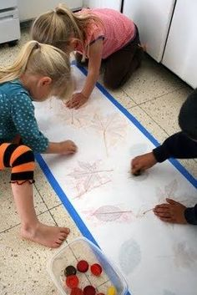  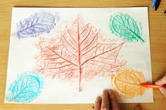
Sink or float?  (Can use worksheet template or complete in green book) | - Fill up a bowl/tub of water  - Investigate a number of objects in the garden or from around the house  - Make a prediction whether the object will sink or float and why you think that before starting the investigation  - Ask: Did the object sink or float?  - Record findings in book or on worksheet
Make a Kite | - Design and make your own kite  - Can use plastic/ paper bags, paper plates, paper to create your own kite  - Other materials used may include recycled materials from around the house  - Once you have made your kite go outside and test it out! | 