Year 6 Home Learning – Week beginning 14.6.21
By 3:30pm each day, please email the year group address year6@stwilfrids-hh.school with details of the reading, writing and maths your child has completed that day. You can also include details of any other project learning or additional activities carried out at home. If you wish, you can also attach photos and any other documents which show this.
Tuesday  15.6.21 | Maths: https://whiterosemaths.com/homelearning/year-6/year-6-projects/ - Summer Week 6-12 - Year 6 White Rose Bakery- Download resources. Today, you should watch the video up to 5 minutes 42 seconds. You should then complete ‘Activity 1’ using ‘Activity 1 resources’. If you need any help or support, please look at ‘White Rose Bakery project overview’ and ‘Teaching slides’. All of the worksheets, resources and answers are on the school website. If you want to make the cupcakes and packaging, you can but you don’t have to. You will still be able to do the maths work.  English: You are going to be carrying with our play script learning. Today, you will need to plan your play script. You can choose to use the template on the website or plan in your own chosen way. You can either write an original play script, adapt a known story into a play or adapt ‘Robin and the Sherwood Hoodies’. Please look through the PowerPoint to identify your IALT and SOS and support you.  Reading: Please read a chapter of your own book (or more!) and then write a summary of the key events. Remember, you can use Oxford Owl if you need a new book to read. The log in details are as follows: Username – 6stwilfrids. Password – Kestrels.  Spelling: Go on spelling shed where there are spellings for you to practice. This week you are learning adjectives to describe settings. To help learn your spellings this week, I would like you to draw a picture where in which your words are hidden. Have a look at the example below to help you:  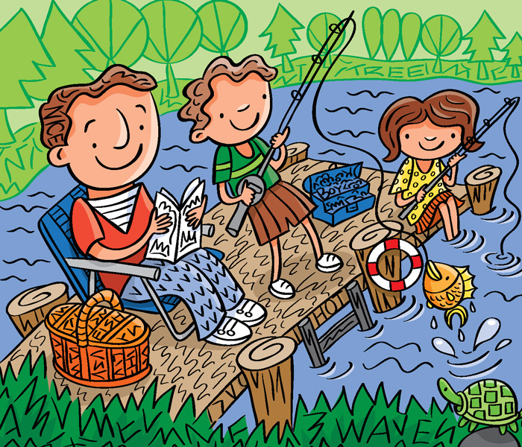  This activity should help you learn your spellings all week. Therefore, you do not have to complete your picture today. If you do, tomorrow you can design another one.  Project learning:  Art and Design - https://classroom.thenational.academy/lessons/understand-what-new-media-art-is-and-create-pixel-art-c4wkgc. Please complete the lesson ‘Understand what New Media Art is and create Pixel Art’ For your activity, I would like you to create your very own pixelated logo, landscape or character. Please use the resource sheet on the website and remember, this can be done in any material you have available.  Computing - https://classroom.thenational.academy/lessons/how-would-you-lay-out-your-web-page-6djp2t. Please complete the lesson ‘Show would you layout your webpage?’. For your activity, I would like you to design a webpage that celebrates everything about you. You can do this on PowerPoint if you have access to it or plain paper if not. Please use the resources on the website to help you. If you want to watch and complete the video and activities from lesson one, you can but you don’t have to. You will still be able to complete this lesson.
Wednesday  16.6.21 | Maths: https://whiterosemaths.com/homelearning/year-6/year-6-projects/ - Summer Week 6-12 - Year 6 White Rose Bakery- Download resources. Today, you should watch the video from 5 minutes 42 seconds to 22 minutes 12 seconds. You should then complete ‘Activity 2’ using ‘Activity 2 resources’. If you need any help or support, please look at ‘White Rose Bakery project overview’ and ‘Teaching slides’. All of the worksheets, resources and answers are on the school website.  English: Today, you will need to write a draft of your play script. Remember to lay it out accurately and use your plan to help. Please look through the PowerPoint to identify your IALT and SOS and support you.  Reading: Please read a chapter of your own book (or more!) and then write a prediction of what will happen next. Remember, you can use Oxford Owl if you need a new book to read. The log in details are as follows: Username – 6stwilfrids. Password – Kestrels.  Spelling: Go on spelling shed where there are spellings for you to practice. This week you are learning adjectives to describe settings. To help learn your spellings this week, I would like you to draw a picture where in which your words are hidden.  Project learning:  Drama - https://classroom.thenational.academy/lessons/how-do-you-see-character-75hkcc?step=1&activity=video. Please complete the lesson ‘How do you see character?’. For your activity, I would like you to design your own character and explain how you see them. Please draw them, write a short description of them focusing on what they are like and how they come across.  French - https://classroom.thenational.academy/lessons/describing-clothes-with-colours-c9h6at. Please complete the lesson ‘Describing clothes with colours’. For your activity, I would like you to create a poster that shows what you have learnt.
Thursday  17.6.21 | Maths: https://whiterosemaths.com/homelearning/year-6/year-6-projects/ - Summer Week 6-12 - Year 6 White Rose Bakery- Download resources. Today, you should watch the video from 22 minutes 12 seconds to 31 minutes 30 seconds. You should then complete the ‘Profit and loss’ worksheet. If you need any help or support, please look at ‘White Rose Bakery project overview’ and ‘Teaching slides’. All of the worksheets, resources and answers are on the school website.  English: Today, you will need to edit and improve the draft of your play script. Remember to use a different colour and reflect on a range of things. Are your spellings accurate? Is the layout accurate? Have you accurately used play scrip features? Please look through the PowerPoint to identify your IALT and SOS and support you.  Reading: Please read a chapter of your own book (or more!) and then write a character description of your favourite character. Remember, you can use Oxford Owl if you need a new book to read. The log in details are as follows: Username – 6stwilfrids. Password – Kestrels.  Spelling: Go on spelling shed where there are spellings for you to practice. This week you are learning adjectives to describe settings. Can you think of anymore spellings that follow this pattern? To help learn your spellings this week, I would like you to draw a picture where in which your words are hidden.  Project learning:  Geography - https://classroom.thenational.academy/lessons/how-is-the-population-distributed-in-the-uk-60u62t?step=2&activity=video. Please complete the lesson ‘How is the population distributed in the UK?’ For your activity, I would like you to label the map of the UK with the four nations and their capitals. I would then like you to colour your map appropriately to show how the population is distributed throughout those nations.  Music - https://classroom.thenational.academy/lessons/to-sing-in-canon-71j3gr. Please complete the lesson ‘To sing in canon’. You won’t need to produce written work to go alongside this lesson unless you wish to.
Friday  18.6.21 | Maths: https://whiterosemaths.com/homelearning/year-6/year-6-projects/ - Summer Week 6-12 - Year 6 White Rose Bakery- Download resources. Today, you should watch the video from 31 minutes 30 seconds to 41 minutes 53 seconds. You should then complete the ‘Packaging’ worksheet. If you need any help or support, please look at ‘White Rose Bakery project overview’ and ‘Teaching slides’. All of the worksheets, resources and answers are on the school website.  English: Today, you will need to publish your play script play script. Remember to ensure that you are using the correct layout. Please look through the PowerPoint to identify your IALT and SOS and support you.  Reading: Please read a chapter of your own book (or more!) and then write a prediction of what will happen next. Remember, you can use Oxford Owl if you need a new book to read. The log in details are as follows: Username – 6stwilfrids. Password – Kestrels.  Spelling: Go on spelling shed where there are spellings for you to practice. This week you are learning adjectives to describe settings. To help learn your spellings this week, I would like you to draw a picture where in which your words are hidden.  Project learning:  History - https://classroom.thenational.academy/lessons/how-did-the-bronze-age-change-how-humans-lived-6dhpce. Please complete the lesson ‘How did the bronze age change how humans lived?’. For your activity, I would like you to create a poster or some form of presentation to answer the lesson question. This could be a PowerPoint, podcast, news report etc. be as creative as you can.  PE - https://classroom.thenational.academy/lessons/dynamic-warming-up-and-introducing-the-heave-throwing-action-70rk2c. Please complete the lesson ‘Dynamic warming up and introducing the heave throwing action’. Don’t worry if you don’t have all the equipment they suggest, get creative! For example, if you don’t have a tennis ball, use a pair of socks! You don’t have to produce written work for this lesson, but you can send in pictures/videos of you doing the activities if you wish.
Monday  21.6.21 | Maths: https://whiterosemaths.com/homelearning/year-6/year-6-projects/ - Summer Week 6-12 - Year 6 White Rose Bakery- Download resources. Today, you should watch the video from 41 minutes 53 seconds to 48 minutes 09 seconds. You should then complete the ‘Cooking problems’ worksheet. If you need any help or support, please look at ‘White Rose Bakery project overview’ and ‘Teaching slides’. All of the worksheets, resources and answers are on the school website.  English: This week, we are going to start a new unit where we write a biography. This is going to be about someone famous who has overcome adversity and therefore, shown ‘what it takes to make it’. Today, I would like you to do look through some biographies and highlight their features. Make a list of them so that you will know what to include in your own writing. Use the WAGOLL’s to help you.  Reading: Please read a chapter of your own book (or more!) and then write your own version of the next chapter. Once you are done, read the next chapter and see if there are any similarities. Remember, you can use Oxford Owl if you need a new book to read. The log in details are as follows: Username – 6stwilfrids. Password – Kestrels.  Spelling: Go on spelling shed where there are spellings for you to practice. This week you are learning vocabulary to describe feelings. To help learn your spellings this week, I would like you to play rounders! Put four bases in the garden and spell your words out loud. When you get one correct, move base. How many rounders can you score?  Project learning:  RE - https://classroom.thenational.academy/lessons/how-do-sikhs-express-their-faith-today-cgr3jd. Please complete the lesson ‘How do Sikhs express their faith today?’ For your activity, I would like you to create a presentation explaining what you have learnt. This can be in any form you wish but should be creative as possible. For example, you could do a video presentation, news report, PowerPoint etc.  PSHE - https://classroom.thenational.academy/lessons/fireproof-64t3er. Please complete the lesson ‘Fireproof’. For your activity, I would like you to produce a poster that promotes fire safety within the home.
Tuesday  22.6.21 | Maths: https://whiterosemaths.com/homelearning/year-6/year-6-projects/ - Summer Week 6-12 - Year 6 White Rose Bakery- Download resources. Today, you should watch the rest of the video from 48 minutes 09 seconds. You should then complete ‘Activity 6’ using ‘Activity 6 – Cooking instructions’. If you need any help or support, please look at ‘White Rose Bakery project overview’ and ‘Teaching slides’. All of the worksheets, resources and answers are on the school website.  English: Today, I would like you to do some research and find out about someone famous who has overcome adversity. Think about the features you picked out yesterday and research in a way that you will be able to include these features. If you want to, you can research multiple people. Collate what you have found in note form.  Reading: Please read a chapter of your own book (or more!) and then write a review of the book you are reading. Remember, you can use Oxford Owl if you need a new book to read. The log in details are as follows: Username – 6stwilfrids. Password – Kestrels.  Spelling: Go on spelling shed where there are spellings for you to practice. This week you are learning vocabulary to describe feelings. To help learn your spellings this week, I would like you to play rounders! Put four bases in the garden and spell your words out loud. When you get one correct, move base. How many rounders can you score?  Project learning:  Science - https://classroom.thenational.academy/lessons/what-happens-to-particles-during-burning-cctp2d. Please complete the lesson ‘What happens to particles during burning?’ for your activity, I would like you to use the worksheets to complete the activities in the video as you go along. If you want (and you have adult support/supervision), you could create and complete your own investigation into what happens to particles during burning.  Spanish - https://classroom.thenational.academy/lessons/saying-the-names-of-6-pets-ctk6cd. For your activity, I would like you to create a poster that shows what you have learnt.

