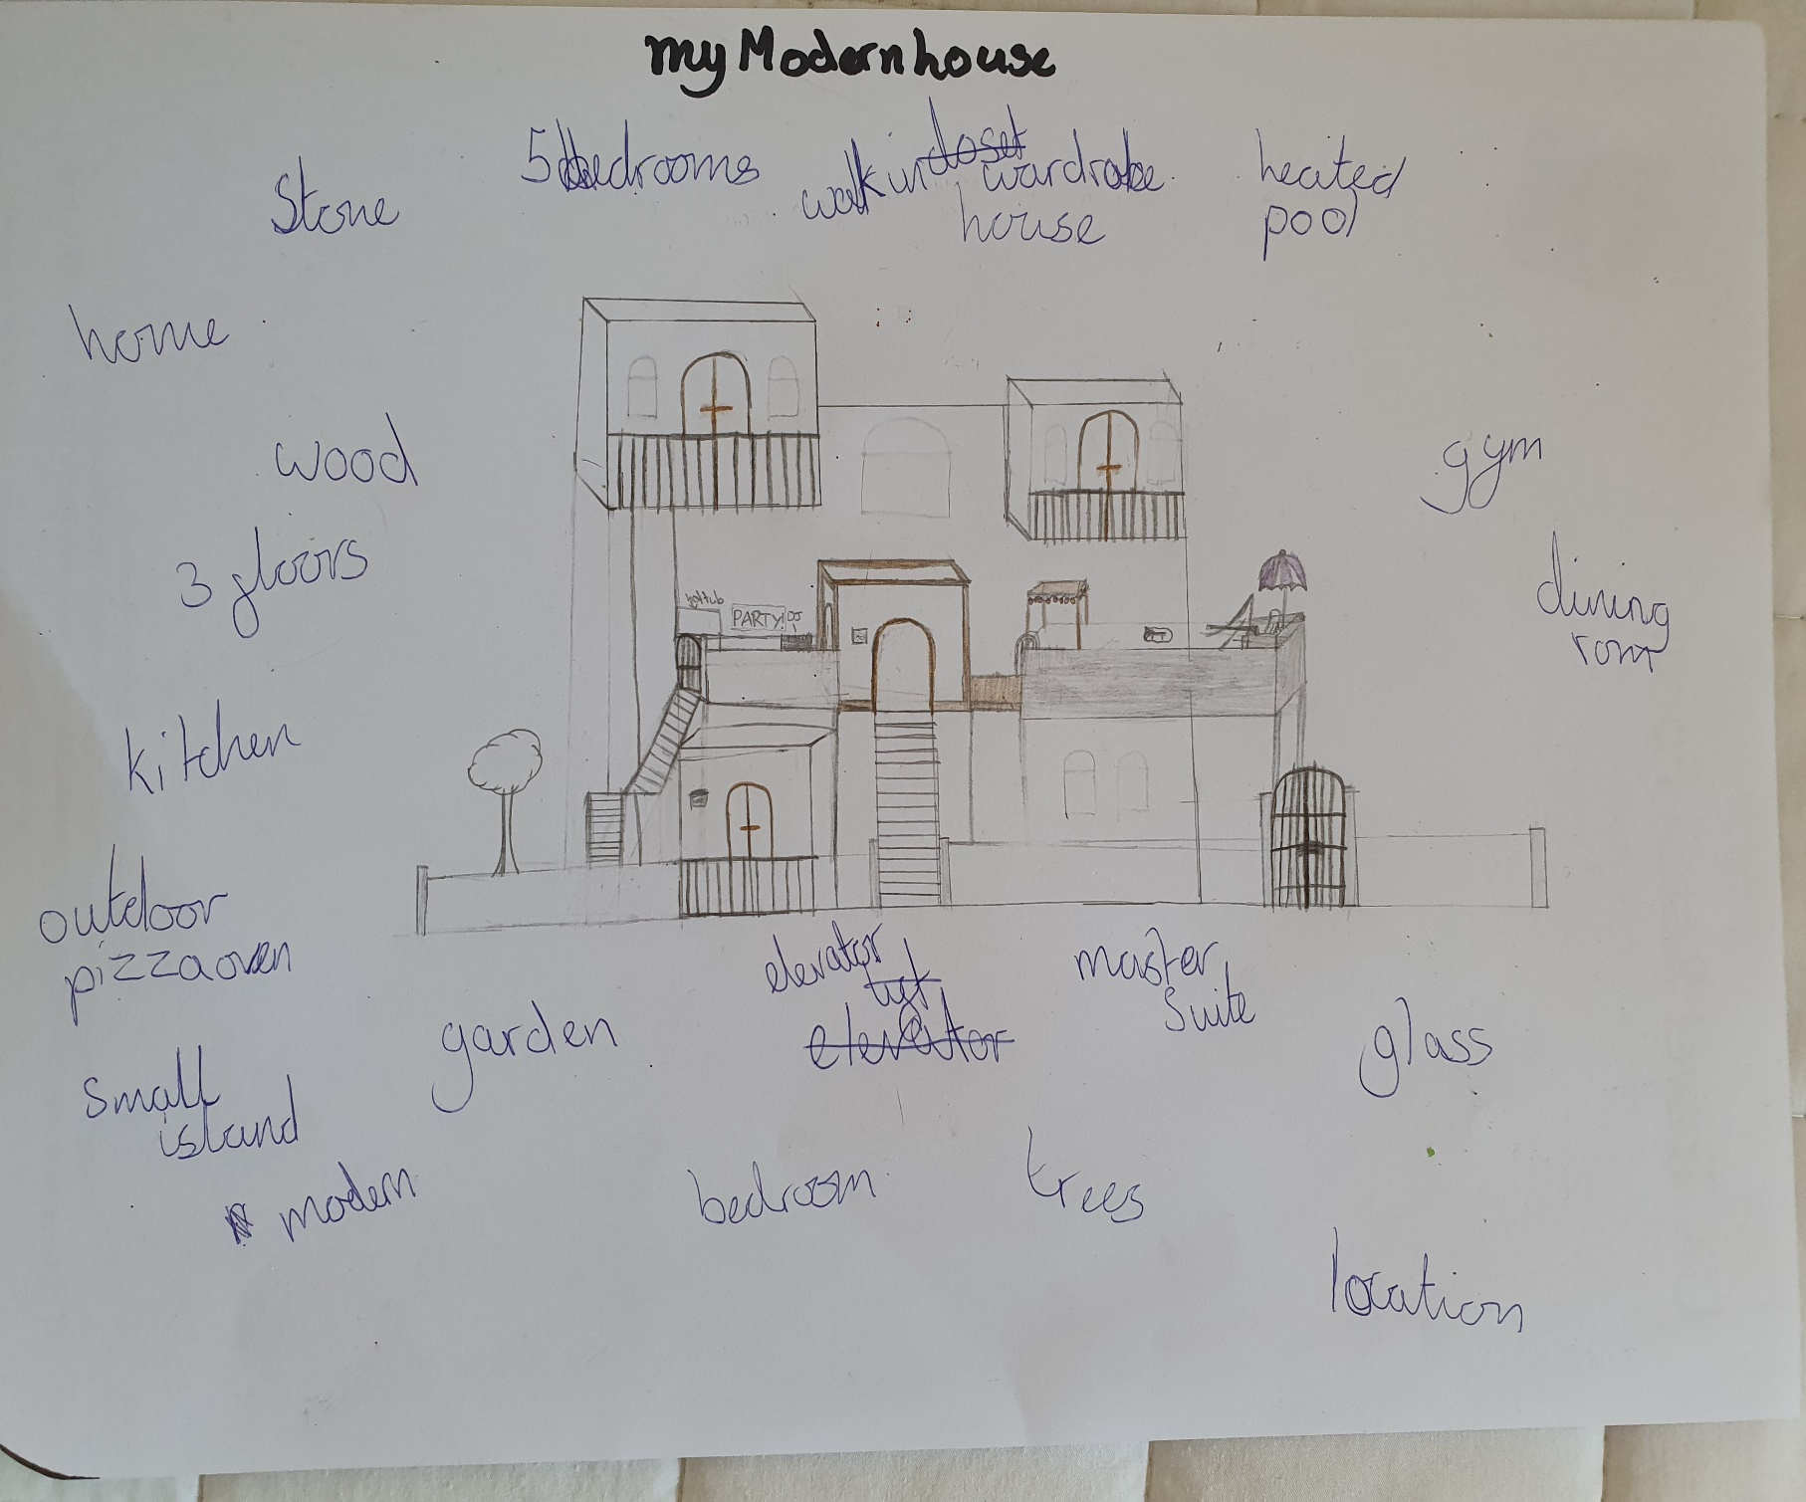\\\

£2.6M

5 Bedroom

7 Bathroom

2 Reception

About the first floor

The lovely kitchen in the house has granite topped counters and a granite island in the middle of it, it has modern fixtures and fittings included. The light and airy living room has a lovely tv on the wall with good quality and a modern fireplace and the second one has a tv on the wall. The bathroom has a warm jacuzzi in it along with a top of the range fittings. The main entrance room has a bar stand in it with a lovely seating area.

About the second floor

The second floor has a lovely bathroom with a jacuzzi and top of the range fittings. This magnificent house includes a master bedroom with a walk-in wardrobe and an en-suite bathroom. All the bedrooms in this magnificent house have walk-in wardrobes and en-suite bathrooms. This amazing house has 2 lovely rooms which have balconies in them.

Heath Mansion, Haywards Heath

Unique 5 bedroom, 7 bathroom modern mansion built in 2020 has lots of unique features to offer. This fantastic modern mansion is perfect for a big family. There are 3 floors which all have lots of space and are light and airy.

Location

This beautiful home is located in the glorious country side of Haywards Heath. This gorgeous town has lots of kind and friendly neighbours. Haywards Heath features a variety of fun places to hang out with your friends and an array of wildlife. This wildlife – filled town a number of restaurants where you can go and eat lots of yummy food

Cool Features

This magnificent house features a top of the range heated swimming pool with a cool little area which is covering a small area of the pool. The main entrance room of this great mansion is made out of glass. This deluxe mansion also includes working escalators instead of stairs. The beautiful garden, which has a very big patio, is 1 acre big.

About the Ground Floor

The ground floor in this mansion has a big garage perfect for 2 cars. This great mansion has a driveway which is lined with pretty red roses. This mansion has a spare room in it which has a tv on the wall and a gym.