Islands – a paradise or in peril?
By Oliver Atkin
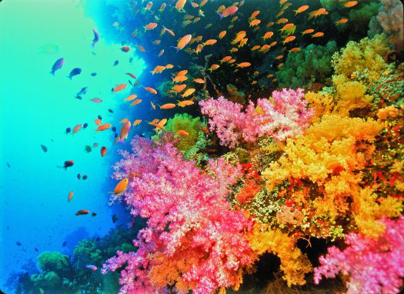

PROS
Islands are a paradise
- A variety of unique plants
- Animals only found on islands such as the tropical penguin
- Beautiful sandy beaches
- Amazing turquoise seas
- Amazing sea life and colorful coral refs
- Lovely weather all year round
- Indigenous people
- Some species of birds only found on islands
- Giant tortoises
- Reptiles only found on specific islands
- Vegetation is lush
- Locals are friendly and welcoming

CONS
Islands in peril
- Global warming - rising temperatures in the oceans that kills the coral reefs and sea life, lack of oxygen suffocates fish, forest fires, plants and animals unable to adapt, hurricanes, droughts
- Plastic left by tourists - animals mistake for food and get themselves caught him which could lead them to die
- Micro plastics in the ocean get into food chain
- Growing human population leads to loss of unique habitat
- Invasive plant and animal species
- Rising sea level – eight islands already lost, sea due to rise by up to 30 cm in the next 10 years
- Oil and plastics in the oceans
- Plants and animals are not able to adapt because of global warming

Conclusion
By looking at the pros and cons, I believe that whilst islands are a paradise, they are in great peril!

