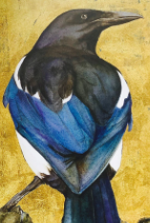

**Heading**

Examples of Exclamation sentences

Expanded noun phrases

Questions to hook the reader



Picture

Amazing Adjectives

Words to persuade the reader

Apostrophes for possession

Apostrophes for Contractions

Picture