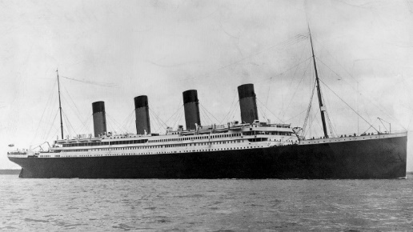
18.1.21 IALT: add the suffixes ‘er’ and ‘est’ to adjectives

Fill in the gaps with an ‘er’ or ‘est’ word. Top tip: check that your word makes sense in the sentence!

- The Titanic was one of the _____________ ships on the ocean.
- It’s funnels were _____________ than lots of other boats.
- The dining room was the ____________ room on the ship.
- The ship’s propellers were ___________ than other ships.
- The Titanic’s swimming pool was the ____________ in the world.

Now see if you can write two sentences of your own using your new ‘er’ and ‘est’ words:
___________________________________________________________________________
___________________________________________________________________________
___________________________________________________________________________
___________________________________________________________________________

Flower challenge: can you write a sentence using your ‘er’ and ‘est’ words and a possessive apostrophe?
___________________________________________________________________________
___________________________________________________________________________

