Your spellings for this week are either words with the suffixes –ness and –ment OR the challenge words. Check on SpellingShed to see which words have been set for you.

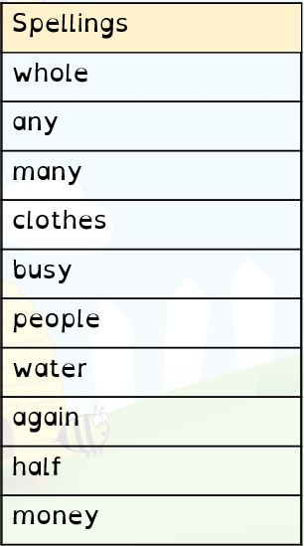
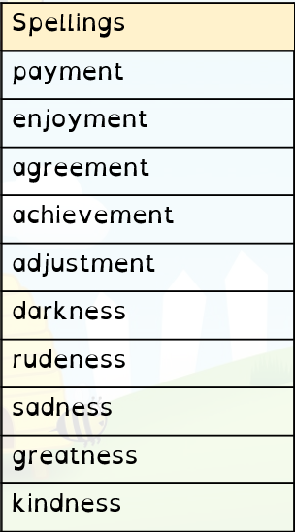
Suffixes Challenge words

